Jenkins Tests Recovery operations support

When looking into the options we have in ALM, we see the following is available to the users:
At the level of the test set, the user can configure what he would like to do in case a certain test in the test set fails:
- The user can rerun the failed test (x amount of retry runs are available for the user to select)
- The user can also utilize a cleanup test to be executed before the re-run is performed
- The user can define what to do in case retry (reruns) still failed
- The user can also define the maximum amount of test set reruns
- The user can also define what to do when reaching a final failure (after several retry operations):
  - Do nothing
  - Stop the test set execution
  - Rerun the entire test set
- There are also test specific settings (like the above option to rerun the specific test or have a specific cleanup test) available in ALM

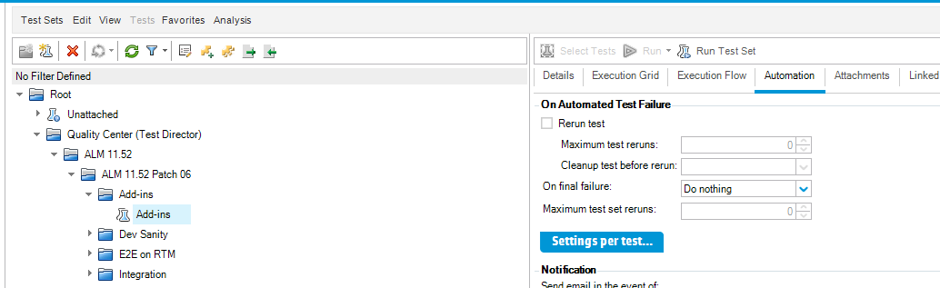
The Settings per test dialog in ALM:
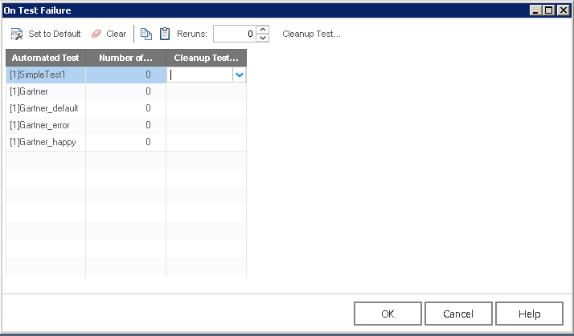
What should we do for Jenkins at this point of time?
We will add our new recovery options into the UFT-Specific Settings area:
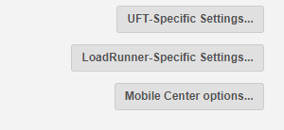
Once the user clicks the above UFT-Specific Settings…” the following will appear:
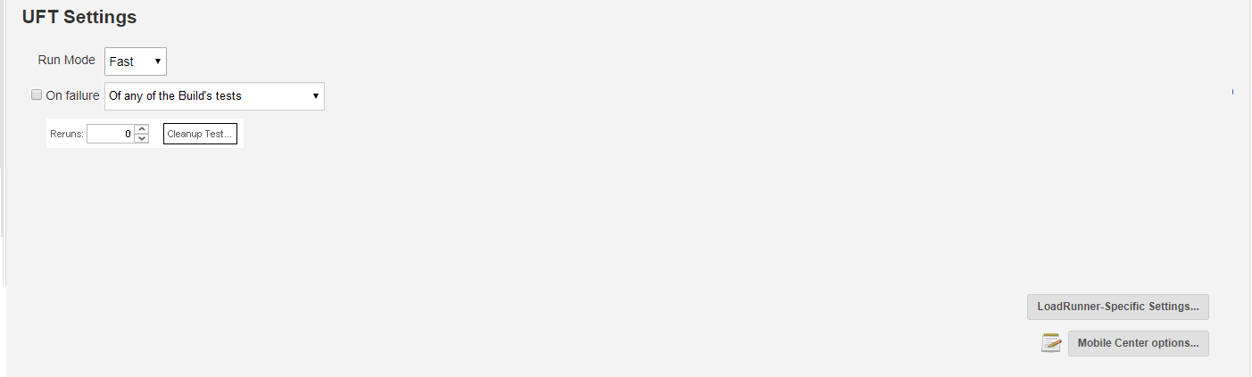
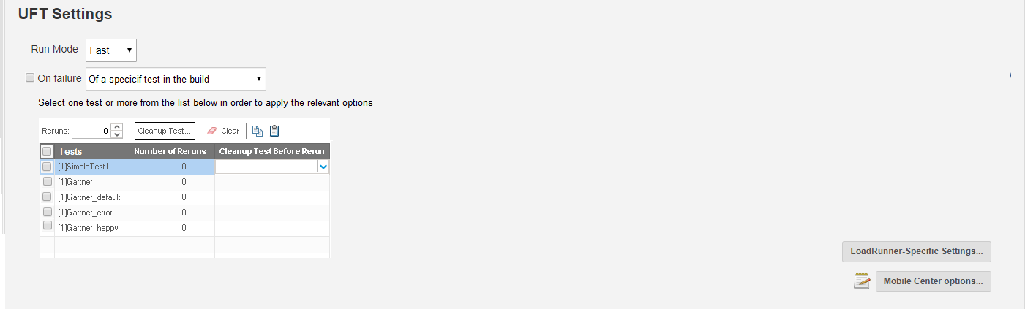
General explanations for the above proposed UI:
- If the user checks ON the “On failure” checkbox, the “On failure” combobox will become enabled.
- Once enabled the user will be able to either select the “Of any of the build’s tests” or the “Of a specific test in the build” options.
  - For the “Of any of the build’s tests” the following operations will become available:
    - Reruns – an option to select how many reruns will be performed
    - Cleanup test – an option to define a cleanup test that will be executed before each of the test’s reruns
When the Cleanup test button is clicked, a browse dialog will be available for the user to select the cleanup test
  - For the “Of a specific test in the build” the following operations will become available
    - The list of the tests in this build step will be presented to the user in a table similar to the table illustrated above
    - Note: when dealing with several tests that are represented by a folder in the build step, we will need to detail all the tests under that folder.
    - The user will be able to either select one test in the list or several and apply different functionality on them:
      - Rerun – similar to the one explained above only impacting the list of selected tests
      - Cleanup test - similar to the one explained above only impacting the list of selected tests
      - Clear (P1) – this will clear any cleanup / rerun settings the user had applied thus far on the table
      - Copy & Paste option (P1) – to allow the user a copy from one test setting (the cleanup and rerun that were set for one test) on to another test in the table.
Notes:
We should also make these recovery / rerun options available when running in parallel run mode. Nevertheless, we might need to consider this as a limitation for the first release (depending on the complexity of addressing parallel execution with this respects).

